3GPP TSG-RAN WG1 #125 R1-2604575
Dalian, China, May 18th – 22nd, 2026

Agenda item: 10.8.1
Source: University of Sheffield
Title: Discussion on ISAC Waveform for 6GR
Document for: Discussion

Introduction
This discussion document has been submitted by the University of Sheffield, UK.

The University of Sheffield has developed a new OFDM-based waveform for consideration in 6GR termed Orthogonal Sequence Division Multiplexing (OSDM).

The initial results presented in this document build on R1-2601539 [1], R1-2602259 [2] and R1-2604574 [3] for the ISAC application. The OSDM waveform inherently possesses advantageous properties for joint radar sensing and communication as discussed below.

2. Justification
Figure 1 depicts a generic schematic block diagram of an OSDM based transceiver.

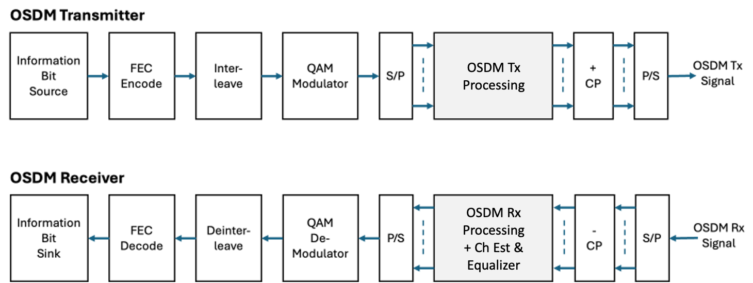

Figure 1: OSDM transceiver for wireless sensing and communication

2.1 Basic ISAC performance comparison
Table 1 compares the salient ISAC waveform properties of OSDM and standard OFDM for an FFT size of 1024.

Feature | OSDM | Standard OFDM
PAPR | ~2.8 dB (High Efficiency) | ~10 dB (Low Efficiency)
Doppler Tolerance | High (Shift causes delay) | Low (Shift causes Inter-Carrier Interference)
Sensing Accuracy | Excellent (Pulse Compression) | Moderate (Requires complex processing)
Complexity | Simple Matched Filter | Complex FFT/Equalization

2.2 Sensing Performance
Figure 1 compares the range sidelobe characteristics of OSDM and OFDM for an FFT size of 1024. OSDM displays lower range sidelobes than OFDM.

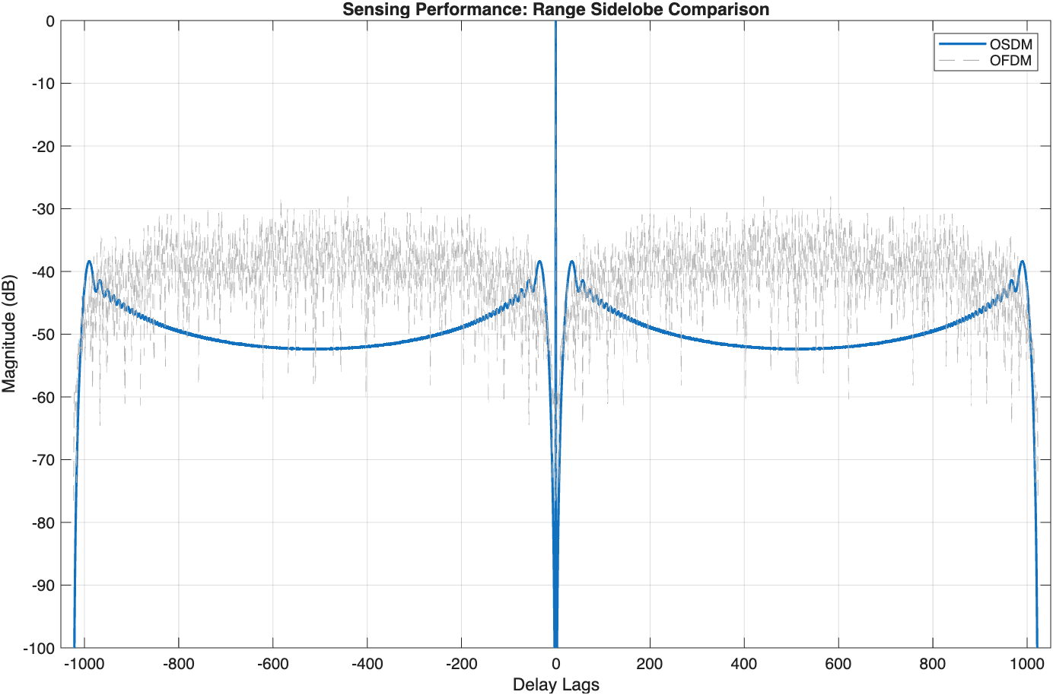
Figure 1: Range sidelobe Comparison

3. Discussions - OSDM ISAC Performance Profile
Sensing: Range & Doppler
- Mainlobe Resolution: OSDM has a highly predictable "time-bandwidth product" with longer waveforms significantly increases the processing gain.
- Sidelobe Suppression: The OSDM waveform inherently possesses low Range Sidelobes. While a raw chirp has sidelobes around -13 dB, OSDM pushes sidelobes down to -25 dB or -30 dB.
  - Impact: This would allow tan OSDM ISAC system to see a pedestrian walking next to a parked car without the car's reflection masking the human.
- Ambiguity Function: Pure OSDM exhibits a "ridge" (slanted peak) in the 2D Ambiguity Function. This provides high Doppler tolerance while requiring compensation for Range-Doppler coupling.

Communication: Hardware & Efficiency
- OSDM PAPR (Peak-to-Average Power Ratio): ~2.8 dB.
  - Comparison: This is significantly better than the ~10 dB of OFDM.
  - OSDM in ISAC mode is highly efficient for the Power Amplifier (PA). A higher power can be transmitted without "clipping" the OSDM waveform.
- Spectral Mask: The naturally smooth "entry and exit" taper of the OSDM pulse reduces Out-of-Band (OOB) emissions.

4. Conclusions
The following observations and proposal are made:
Observation 1: OSDM for sensing has a lower PAPR than OFDM.

Observation 2: OSDM for sensing has lower range sidelobes than OFDM.

Observation 3: OSDM can combine sensing and communication simultaneously.

Proposal: To further explore OSDM as a candidate ISAC waveform for 6GR

References
- 3GPP RP-2601539, New Waveform for 6G - OSDM, 3GPP TSG RAN1 Meeting #124, Gothenburg, Sweden, February 9-13, 2026.
- 3GPP RP-2602259, New Waveform for 6G - OSDM, 3GPP TSG RAN1 Meeting #124bis, St. Julian’s, Malta, April 13-17, 2026.
- 3GPP RP-2604574, New Waveform for 6G – OSDM Further Results, 3GPP TSG RAN1 Meeting #125, Dalian, China, May 18-22, 2026.

